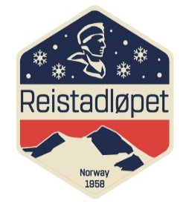

Race: Reistadløpet 2018
Date: 7.th. of April 2018 at 12.30.pm
Place: Bardufoss

Jury-meeting after the race
1. Opening of the meeting: Bardufoss skisenter at 12.30hrs
2. Present: FIS-TD Thomas Granlund, Ass.National TD Arne Vedvik, Visma Race Director Robert Peets, COC Fred Arne Jakobsen, Ass. COC Håvard Østvik, , Race Secretary Toril Skaflestad
3. Ratification of the agenda: OK
4. Protests: No protests
5. Sanctions
- Disqualification: None
- Competition suspension: None
- Time penalty: None
- Written reprimand: None
- Monetary fine: None
- Verbal reprimand: 1. One member of the team Lager 157.
6. Other reports
- COC: Everything went according to plan.
- TD: Splendid race. Course good, tracks mostly good. Suggestions for improvements: Look at grooming from Kampenhytten to finish, regrooming of the finish was necessary. Consider if the 34k should start later than the 50k so as to avoid both groups entering the finish area at the same time. More toilets in the start area.
- RD: fair race, grooming good, probably the best this season.
7. Result lists: 1289 entries, 1167 finished.
8. Other matters: None
9. Preparation for next day of competition: Not valid
10. Next meeting: Not valid
11. Closure of the meeting: Looking forward to next year’s event.

Toril Skaflestad (sign) Thomas Granlund (sign)
Race Secretary Technical Delegate

