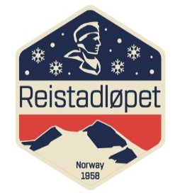 

Race: Reistadløpet 2018

Date: 7.th. of April 2018 at 7.am

Place: Setermoen

Jury-meeting

1. Present: Thomas Granlund, Robert Peets, Arne Vedvik, Fred Arne Jakobsen, Håvard Østvik, Ingvar Kristensen, Toril Skaflestad

2. Ratification of the agenda: OK

3. Weather forecast: heavy snow and wind during the night, 1 cm of fresh snow at the moment but less wind in the morning than during the night. Good development.

Avalanche hazard: steady condition.

4. Reports about the preparations/observations

* **COC:** Grooming from Orta to Kampenhytta finished at 09.15. Tracks good.
* **RD**:
* **FIS TD**:
* Forerunners at the sprint at Storlømyra. Also forerunners spread out at Sundlifjellet.
* Random control of pole-length at the finish area.
* **Ass.TD**: no comments

14. Next meeting: at Bardufoss at approx 11.30am

Toril Skaflestad Thomas Granlund

Race Secretary Technical Delegate

 

Race: Date:

Place:

Jury-meeting **after** the race

1. Opening of the meeting

2. Present

3. Ratification of the agenda

4. Protests

5. Sanctions

* Disqualification
* Competition suspension
* Time penalty
* Written reprimand
* Monetary fine
* Verbal reprimand

6. Other reports

* COC:
* TDA:
* TD:

7. Result lists

8. Other matters

9. Preparation for next day of competition

10. Next meeting

11. Closure of the meeting

Race Secretary Technical Delegate